**Name:** Tyler Han

**Article Authors:** Virendra Patidar, Ritu Tiwari

**Article Title:** Survey of robotic arm and parameters

**Publisher:** IEEE

**Year of Publication:** 2016

**Purpose of the study:** To give a technical introduction to recent research in the field of robotic arm development.

**Research Questions:** Analysis of the parameters used in robotic arm design

**Current Knowledge on Topic:** Important factors of consideration are the axes of rotation, degrees of freedom, working envelope and working space, kinematics, payload, speed and acceleration, accuracy and repeatability, and finally motion control and drive. In considering the axes of rotation of a robotic arm, the space in which the arm is capable of moving around freely in must be accounted for (i.e. one axis represents a line, two a plane, and three a space). Degrees of freedom will provide the arm with control over these points. The human arm has 7 degrees of freedom and has a considerable amount of control (as we experience first hand) over the space in which it resides. The spatial control can be calculated by mathematical analysis of the axes at each joint. The working envelope/space is the encircled space due to each joint of the arm (right). A robot can only operate within these envelopes unless otherwise accounted for (i.e. a track on which the arm would move across). Complete or full working space can be defined by the region in which the arm operates without any obstacle. The kinematics of an arm are defined first by a chosen coordinate system (spherical, cartesian, etc.). Analysis of the kinematics (motion, inertia, and mass at time *t* and joint *x*) predict and plan the motion of the arm. Robotic redundancy is defined by and results from when there are more axes of freedom than necessary to complete a certain task or movement. This means that there is more than one way to navigate the arm in this situation and thus motion planning becomes difficult. Solutions to redundancy are found in robotic vision. Approaches to trajectory planning include machine learning, specifically imitation learning, where the robotic arm is trained to make decisions that would mimic the behaviors of a human arm. Payload is the weight which the arm must be able to carry and operate under. Speed and acceleration are factors which are affected by the range of motion and joints of the robotic arm, as each joint of the arm likely results in larger and larger moment arms and larger changes in motion of the end effector. Accuracy and repeatability are vital in robotic arm development since a robotic arm has a primary goal of automation. Reiterative testing is crucial in this segment of development and should be used to hone the robot’s precision in its tasks. Finally motion control and drive takes into consideration the interoperability of each of the joint’s motors.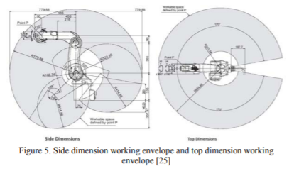

**Results/Future Work:** Research areas in robotic arm development include improvement of envelope space, motion control, and accuracy and repeatability.

**Relation to Project:** Every parameter (axes of rotation, degrees of freedom, working envelope and working space, kinematics, payload, speed and acceleration, accuracy and repeatability, and finally motion control and drive) must be considered when the team develops the robotic arm. We must consider how the 3D printer will interact with the arm in regards to each of these parameters and how far a limited understanding of these concepts will take us.

**Sources:** The author cited over 40 other robotic arm designs and implementations. Their research was heavily incorporated and analyzed for the purposes of the article. The data was sufficient for the question/target of the paper.

**Influence:** After reading the current research and introduction to the development of a robotic arm, I realize that we are entering an already vastly researched world.